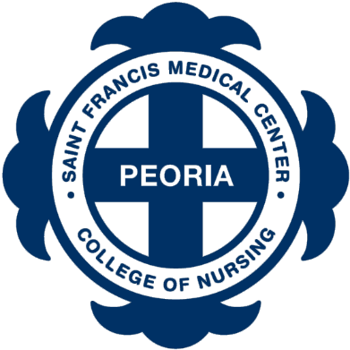
Fall 2024 Dorm Room Application

Return by one of the following:
Email to: elizabeth.k.zaluska@osfhealthcare.org
Fax to: 309-624-8973
Mail to: Saint Francis Medical Center College of Nursing
511 NE. Greenleaf St, Peoria, IL. 61603

Student information: (Please Print)

Last Name |  | First Name |  | Middle Initial

Phone Number |  | Email

Current Street Address

City |  | State |  | Zip Code

Permanent Street Address (leave blank if same as current address)

City |  | State |  | Zip Code

Gender: | ☐ Male | ☐ Female

Comments or Special Circumstances:
List any comments or special circumstances that should be taken into consideration when reviewing your application for a dorm room:

Student Certification:

Student Signature |  | Date

