LOGO Cent FNL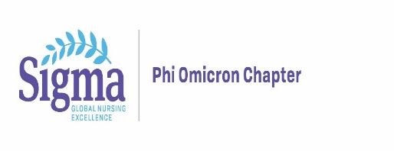

**Saint Anthony College of Nursing/ Sigma Theta Tau Phi Omicron**

**Annual Pharmacology Update**

**Friday, November 1st, 2024, 9:30 AM to 5:00 PM**

**NIU Conference Center, 8500 E. State Street, Rockford, IL 61108**

**Participant Registration Form**

Participant Name with credentials*



Organizational Affiliation



Email*



SACN or SFMC CON Student $50 ______

SACN or SFMC CON Faculty $50 ______

SACN or SFMC CON Alumni $50 ______

STTI Member $50 ______

SACN Preceptor No Fee ______

All other Participants $100 ______

Box Lunch Options (please state your selection in the box below)

* Choice of **Turkey, Ham, Roast Beef or Veggie Stack** sandwich along with pasta salad and cookie
* **Gluten free salad with or without grilled chicken**

All lunches come with fruit.



**Please return form: Natia.Y.Foster@osfhealthcare.org**

**OR Mail to:**

Saint Anthony College of Nursing

Sigma Theta Tau Phi Omicron Chapter  
Attn: Natia Foster

3301 North Mulford Road

Rockford, Illinois 61114

**Payment Options:**

**Check payments**: Please make check payable to Sigma Theta Tau Phi Omicron Chapter and mail to address above **OR**

**Paypal**: [STTI493@gmail.com](mailto:STTI493@gmail.com) (please include your name in the notes section)

**You will receive a confirmation email once payment and registration is received.**